Basis Data Part 5
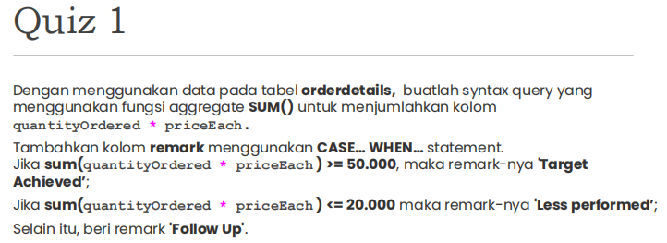
SELECT
orderNumber,
SUM(quantityOrdered * priceEach) AS total_penjualan,
CASE
WHEN SUM(quantityOrdered * priceEach) >= 50000 THEN 'Target Achieved'
WHEN SUM(quantityOrdered * priceEach) <= 20000 THEN 'Less performed'
ELSE 'Follow Up'
END AS remark
FROM orderdetails
GROUP BY orderNumber;
+-------------+-----------------+-----------------+
| orderNumber | total_penjualan | remark |
+-------------+-----------------+-----------------+
| 10100 | 10223.83 | Less performed |
| 10101 | 10549.01 | Less performed |
| 10102 | 5494.78 | Less performed |
| 10103 | 50218.95 | Target Achieved |
| 10104 | 40206.20 | Follow Up |
| 10105 | 53959.21 | Target Achieved |
| 10106 | 52151.81 | Target Achieved |
| 10107 | 22292.62 | Follow Up |
| 10108 | 51001.22 | Target Achieved |
| 10109 | 25833.14 | Follow Up |
| 10110 | 48425.69 | Follow Up |
| 10111 | 16537.85 | Less performed |
| 10112 | 7674.94 | Less performed |
| 10113 | 11044.30 | Less performed |
| 10114 | 33383.14 | Follow Up |
| 10115 | 21665.98 | Follow Up |
| 10116 | 1627.56 | Less performed |
| 10117 | 44380.15 | Follow Up |
| 10118 | 3101.40 | Less performed |
| 10119 | 35826.33 | Follow Up |
| 10120 | 45864.03 | Follow Up |
| 10121 | 16700.47 | Less performed |
| 10122 | 50824.66 | Target Achieved |
| 10123 | 14571.44 | Less performed |
| 10124 | 32641.98 | Follow Up |
| 10125 | 7565.08 | Less performed |
| 10126 | 57131.92 | Target Achieved |
| 10127 | 58841.35 | Target Achieved |
| 10128 | 13884.99 | Less performed |
| 10129 | 29429.14 | Follow Up |
| 10130 | 6036.96 | Less performed |
| 10131 | 17032.29 | Less performed |
| 10132 | 2880.00 | Less performed |
| 10133 | 22366.04 | Follow Up |
| 10134 | 23419.47 | Follow Up |
| 10135 | 55601.84 | Target Achieved |
| 10136 | 14232.70 | Less performed |
| 10137 | 13920.26 | Less performed |
| 10138 | 32077.44 | Follow Up |
| 10139 | 24013.52 | Follow Up |
| 10140 | 38675.13 | Follow Up |
| 10141 | 29716.86 | Follow Up |
| 10142 | 56052.56 | Target Achieved |
| 10143 | 41016.75 | Follow Up |
| 10144 | 1128.20 | Less performed |
| 10145 | 50342.74 | Target Achieved |
| 10146 | 6631.36 | Less performed |
| 10147 | 32680.31 | Follow Up |
| 10148 | 41554.73 | Follow Up |
| 10149 | 29997.09 | Follow Up |
| 10150 | 38350.15 | Follow Up |
| 10151 | 32723.04 | Follow Up |
| 10152 | 9821.32 | Less performed |
| 10153 | 44939.85 | Follow Up |
| 10154 | 4465.85 | Less performed |
| 10155 | 37602.48 | Follow Up |
| 10156 | 4599.52 | Less performed |
| 10157 | 17746.26 | Less performed |
| 10158 | 1491.38 | Less performed |
| 10159 | 54682.68 | Target Achieved |
| 10160 | 20452.50 | Follow Up |
| 10161 | 36164.46 | Follow Up |
| 10162 | 30876.44 | Follow Up |
| 10163 | 22042.37 | Follow Up |
| 10164 | 27121.90 | Follow Up |
| 10165 | 67392.85 | Target Achieved |
| 10166 | 9977.85 | Less performed |
| 10167 | 44167.09 | Follow Up |
| 10168 | 50743.65 | Target Achieved |
| 10169 | 38547.19 | Follow Up |
| 10170 | 15130.97 | Less performed |
| 10171 | 16909.84 | Less performed |
| 10172 | 24879.08 | Follow Up |
| 10173 | 37723.79 | Follow Up |
| 10174 | 23936.53 | Follow Up |
| 10175 | 37455.77 | Follow Up |
| 10176 | 38524.29 | Follow Up |
| 10177 | 31428.21 | Follow Up |
| 10178 | 33818.34 | Follow Up |
| 10179 | 22963.60 | Follow Up |
| 10180 | 42783.81 | Follow Up |
| 10181 | 55069.55 | Target Achieved |
| 10182 | 45084.38 | Follow Up |
| 10183 | 34606.28 | Follow Up |
| 10184 | 47513.19 | Follow Up |
| 10185 | 52548.49 | Target Achieved |
| 10186 | 22275.73 | Follow Up |
| 10187 | 28287.73 | Follow Up |
| 10188 | 29954.91 | Follow Up |
| 10189 | 3879.96 | Less performed |
| 10190 | 10721.86 | Less performed |
| 10191 | 27988.47 | Follow Up |
| 10192 | 55425.77 | Target Achieved |
| 10193 | 35505.63 | Follow Up |
| 10194 | 39712.10 | Follow Up |
| 10195 | 36092.40 | Follow Up |
| 10196 | 38139.18 | Follow Up |
| 10197 | 40473.86 | Follow Up |
| 10198 | 20644.24 | Follow Up |
| 10199 | 7678.25 | Less performed |
| 10200 | 17193.06 | Less performed |
| 10201 | 23923.93 | Follow Up |
| 10202 | 20220.04 | Follow Up |
| 10203 | 40062.53 | Follow Up |
| 10204 | 58793.53 | Target Achieved |
| 10205 | 13059.16 | Less performed |
| 10206 | 36527.61 | Follow Up |
| 10207 | 59265.14 | Target Achieved |
| 10208 | 49614.72 | Follow Up |
| 10209 | 21053.69 | Follow Up |
| 10210 | 47177.59 | Follow Up |
| 10211 | 49165.16 | Follow Up |
| 10212 | 59830.55 | Target Achieved |
| 10213 | 7310.42 | Less performed |
| 10214 | 22162.61 | Follow Up |
| 10215 | 36070.47 | Follow Up |
| 10216 | 5759.42 | Less performed |
| 10217 | 22474.17 | Follow Up |
| 10218 | 7612.06 | Less performed |
| 10219 | 12573.28 | Less performed |
| 10220 | 32538.74 | Follow Up |
| 10221 | 16901.38 | Less performed |
| 10222 | 56822.65 | Target Achieved |
| 10223 | 44894.74 | Follow Up |
| 10224 | 18997.89 | Less performed |
| 10225 | 47375.92 | Follow Up |
| 10226 | 23552.59 | Follow Up |
| 10227 | 40978.53 | Follow Up |
| 10228 | 20355.24 | Follow Up |
| 10229 | 43369.30 | Follow Up |
| 10230 | 33820.62 | Follow Up |
| 10231 | 15322.93 | Less performed |
| 10232 | 24995.61 | Follow Up |
| 10233 | 7178.66 | Less performed |
| 10234 | 31670.37 | Follow Up |
| 10235 | 29284.42 | Follow Up |
| 10236 | 5899.38 | Less performed |
| 10237 | 22602.36 | Follow Up |
| 10238 | 28211.70 | Follow Up |
| 10239 | 16212.59 | Less performed |
| 10240 | 15183.63 | Less performed |
| 10241 | 36069.26 | Follow Up |
| 10242 | 1679.92 | Less performed |
| 10243 | 6276.60 | Less performed |
| 10244 | 26155.91 | Follow Up |
| 10245 | 32239.47 | Follow Up |
| 10246 | 35420.74 | Follow Up |
| 10247 | 28394.54 | Follow Up |
| 10248 | 41445.21 | Follow Up |
| 10249 | 11843.45 | Less performed |
| 10250 | 42798.08 | Follow Up |
| 10251 | 31102.85 | Follow Up |
| 10252 | 25080.96 | Follow Up |
| 10253 | 45443.54 | Follow Up |
| 10254 | 37281.36 | Follow Up |
| 10255 | 4632.31 | Less performed |
| 10256 | 4710.73 | Less performed |
| 10257 | 16753.30 | Less performed |
| 10258 | 22037.91 | Follow Up |
| 10259 | 44160.92 | Follow Up |
| 10260 | 37769.38 | Follow Up |
| 10261 | 22997.45 | Follow Up |
| 10262 | 47065.36 | Follow Up |
| 10263 | 42044.77 | Follow Up |
| 10264 | 18473.71 | Less performed |
| 10265 | 9415.13 | Less performed |
| 10266 | 51619.02 | Target Achieved |
| 10267 | 20314.44 | Follow Up |
| 10268 | 35034.57 | Follow Up |
| 10269 | 6419.84 | Less performed |
| 10270 | 35806.73 | Follow Up |
| 10271 | 37430.89 | Follow Up |
| 10272 | 23715.70 | Follow Up |
| 10273 | 45352.47 | Follow Up |
| 10274 | 12530.51 | Less performed |
| 10275 | 47924.19 | Follow Up |
| 10276 | 51152.86 | Target Achieved |
| 10277 | 2611.84 | Less performed |
| 10278 | 33347.88 | Follow Up |
| 10279 | 20009.53 | Follow Up |
| 10280 | 48298.99 | Follow Up |
| 10281 | 39641.43 | Follow Up |
| 10282 | 47979.98 | Follow Up |
| 10283 | 37527.58 | Follow Up |
| 10284 | 32260.16 | Follow Up |
| 10285 | 43134.04 | Follow Up |
| 10286 | 1960.80 | Less performed |
| 10287 | 61402.00 | Target Achieved |
| 10288 | 38785.48 | Follow Up |
| 10289 | 12538.01 | Less performed |
| 10290 | 5858.56 | Less performed |
| 10291 | 48809.90 | Follow Up |
| 10292 | 35321.97 | Follow Up |
| 10293 | 33924.24 | Follow Up |
| 10294 | 4424.40 | Less performed |
| 10295 | 15059.76 | Less performed |
| 10296 | 31310.09 | Follow Up |
| 10297 | 17359.53 | Less performed |
| 10298 | 6066.78 | Less performed |
| 10299 | 34341.08 | Follow Up |
| 10300 | 24101.81 | Follow Up |
| 10301 | 36798.88 | Follow Up |
| 10302 | 23908.24 | Follow Up |
| 10303 | 3474.66 | Less performed |
| 10304 | 53116.99 | Target Achieved |
| 10305 | 47411.33 | Follow Up |
| 10306 | 52825.29 | Target Achieved |
| 10307 | 23333.06 | Follow Up |
| 10308 | 42339.76 | Follow Up |
| 10309 | 17876.32 | Less performed |
| 10310 | 61234.67 | Target Achieved |
| 10311 | 36140.38 | Follow Up |
| 10312 | 55639.66 | Target Achieved |
| 10313 | 33594.58 | Follow Up |
| 10314 | 53745.34 | Target Achieved |
| 10315 | 19501.82 | Less performed |
| 10316 | 46788.14 | Follow Up |
| 10317 | 2434.25 | Less performed |
| 10318 | 35152.12 | Follow Up |
| 10319 | 27550.51 | Follow Up |
| 10320 | 16799.03 | Less performed |
| 10321 | 48355.87 | Follow Up |
| 10322 | 50799.69 | Target Achieved |
| 10323 | 7466.32 | Less performed |
| 10324 | 44400.50 | Follow Up |
| 10325 | 34638.14 | Follow Up |
| 10326 | 19206.68 | Less performed |
| 10327 | 20564.86 | Follow Up |
| 10328 | 37654.09 | Follow Up |
| 10329 | 50025.35 | Target Achieved |
| 10330 | 15822.84 | Less performed |
| 10331 | 45994.07 | Follow Up |
| 10332 | 47159.11 | Follow Up |
| 10333 | 26248.78 | Follow Up |
| 10334 | 23014.17 | Follow Up |
| 10335 | 6466.44 | Less performed |
| 10336 | 51209.58 | Target Achieved |
| 10337 | 25505.98 | Follow Up |
| 10338 | 12081.52 | Less performed |
| 10339 | 48927.64 | Follow Up |
| 10340 | 24945.21 | Follow Up |
| 10341 | 42813.83 | Follow Up |
| 10342 | 40265.60 | Follow Up |
| 10343 | 17104.91 | Less performed |
| 10344 | 18888.31 | Less performed |
| 10345 | 1676.14 | Less performed |
| 10346 | 14191.12 | Less performed |
| 10347 | 41995.62 | Follow Up |
| 10348 | 33145.56 | Follow Up |
| 10349 | 39964.63 | Follow Up |
| 10350 | 46493.16 | Follow Up |
| 10351 | 13671.82 | Less performed |
| 10352 | 9658.74 | Less performed |
| 10353 | 26304.13 | Follow Up |
| 10354 | 39440.59 | Follow Up |
| 10355 | 25529.78 | Follow Up |
| 10356 | 26311.63 | Follow Up |
| 10357 | 40676.26 | Follow Up |
| 10358 | 44185.46 | Follow Up |
| 10359 | 32600.61 | Follow Up |
| 10360 | 52166.00 | Target Achieved |
| 10361 | 31835.36 | Follow Up |
| 10362 | 12692.19 | Less performed |
| 10363 | 45785.34 | Follow Up |
| 10364 | 1834.56 | Less performed |
| 10365 | 8307.28 | Less performed |
| 10366 | 14379.90 | Less performed |
| 10367 | 39580.60 | Follow Up |
| 10368 | 13874.75 | Less performed |
| 10369 | 28322.83 | Follow Up |
| 10370 | 27083.78 | Follow Up |
| 10371 | 35137.54 | Follow Up |
| 10372 | 33967.73 | Follow Up |
| 10373 | 46770.52 | Follow Up |
| 10374 | 21432.31 | Follow Up |
| 10375 | 49523.67 | Follow Up |
| 10376 | 3452.75 | Less performed |
| 10377 | 23602.90 | Follow Up |
| 10378 | 32289.12 | Follow Up |
| 10379 | 16621.27 | Less performed |
| 10380 | 34404.21 | Follow Up |
| 10381 | 32626.09 | Follow Up |
| 10382 | 47765.59 | Follow Up |
| 10383 | 36851.98 | Follow Up |
| 10384 | 14155.57 | Less performed |
| 10385 | 4466.71 | Less performed |
| 10386 | 46968.52 | Follow Up |
| 10387 | 3516.04 | Less performed |
| 10388 | 30293.77 | Follow Up |
| 10389 | 27966.54 | Follow Up |
| 10390 | 55902.50 | Target Achieved |
| 10391 | 29848.52 | Follow Up |
| 10392 | 8807.12 | Less performed |
| 10393 | 33593.32 | Follow Up |
| 10394 | 18102.74 | Less performed |
| 10395 | 17928.09 | Less performed |
| 10396 | 27695.54 | Follow Up |
| 10397 | 12432.32 | Less performed |
| 10398 | 46656.94 | Follow Up |
| 10399 | 30253.75 | Follow Up |
| 10400 | 31755.34 | Follow Up |
| 10401 | 43525.04 | Follow Up |
| 10402 | 12190.85 | Less performed |
| 10403 | 37258.94 | Follow Up |
| 10404 | 41426.81 | Follow Up |
| 10405 | 35157.75 | Follow Up |
| 10406 | 21638.62 | Follow Up |
| 10407 | 52229.55 | Target Achieved |
| 10408 | 615.45 | Less performed |
| 10409 | 2326.18 | Less performed |
| 10410 | 36442.34 | Follow Up |
| 10411 | 29070.38 | Follow Up |
| 10412 | 46895.48 | Follow Up |
| 10413 | 28500.78 | Follow Up |
| 10414 | 50806.85 | Target Achieved |
| 10415 | 10945.26 | Less performed |
| 10416 | 35362.26 | Follow Up |
| 10417 | 28574.90 | Follow Up |
| 10418 | 23627.44 | Follow Up |
| 10419 | 52420.07 | Target Achieved |
| 10420 | 42251.51 | Follow Up |
| 10421 | 7639.10 | Less performed |
| 10422 | 5849.44 | Less performed |
| 10423 | 8597.73 | Less performed |
| 10424 | 29310.30 | Follow Up |
| 10425 | 41623.44 | Follow Up |
+-------------+-----------------+-----------------+
326 rows in set (0.04 sec)
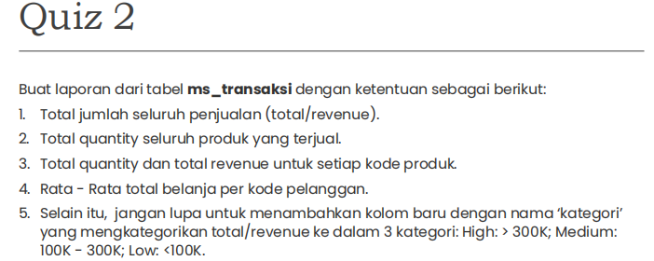
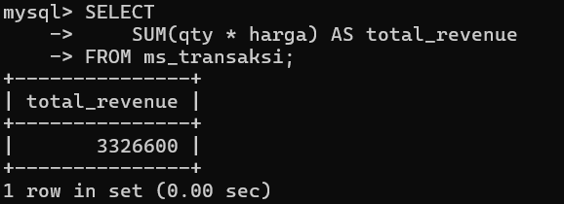
1.

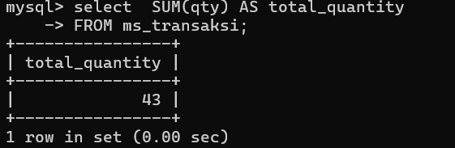
2.

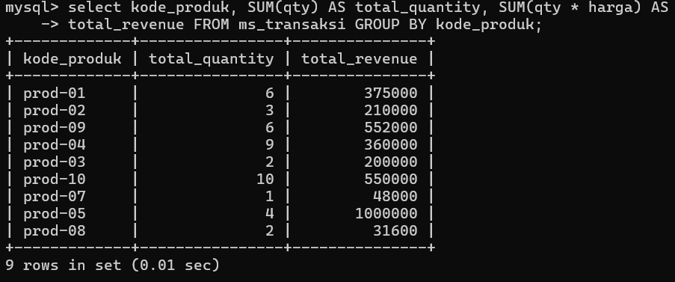
3.

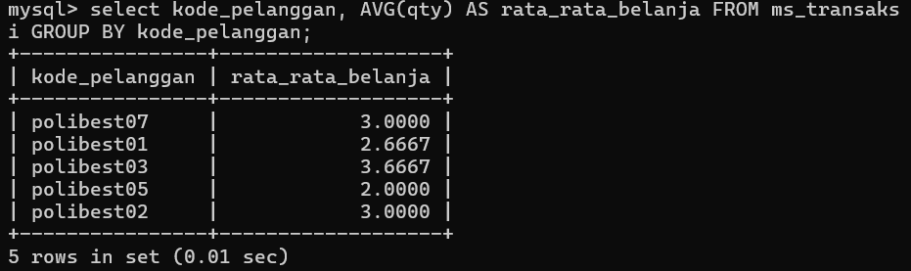
4.

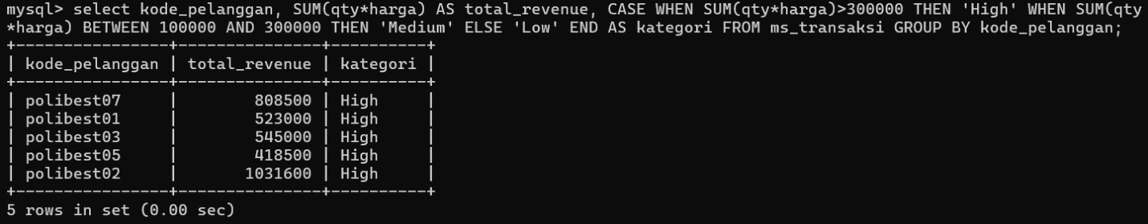
5.

Basis Data Part 6
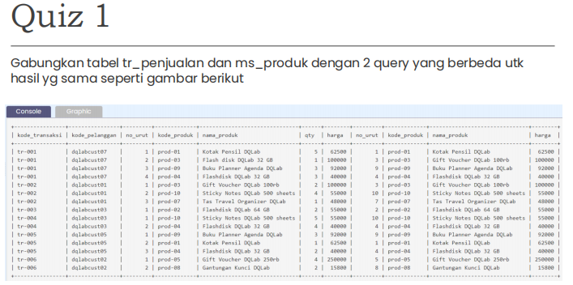
SELECT
-> tr_penjualan.kode_transaksi,
-> tr_penjualan.kode_pelanggan,
-> tr_penjualan.no_urut,
-> tr_penjualan.kode_produk,
-> ms_produk.nama_produk,
-> tr_penjualan.qty,
-> ms_produk.harga,
-> ms_produk.no_urut,
-> ms_produk.kode_produk,
-> ms_produk.nama_produk,
-> ms_produk.harga
-> FROM tr_penjualan
-> INNER JOIN ms_produk
-> ON tr_penjualan.kode_produk = ms_produk.kode_produk;
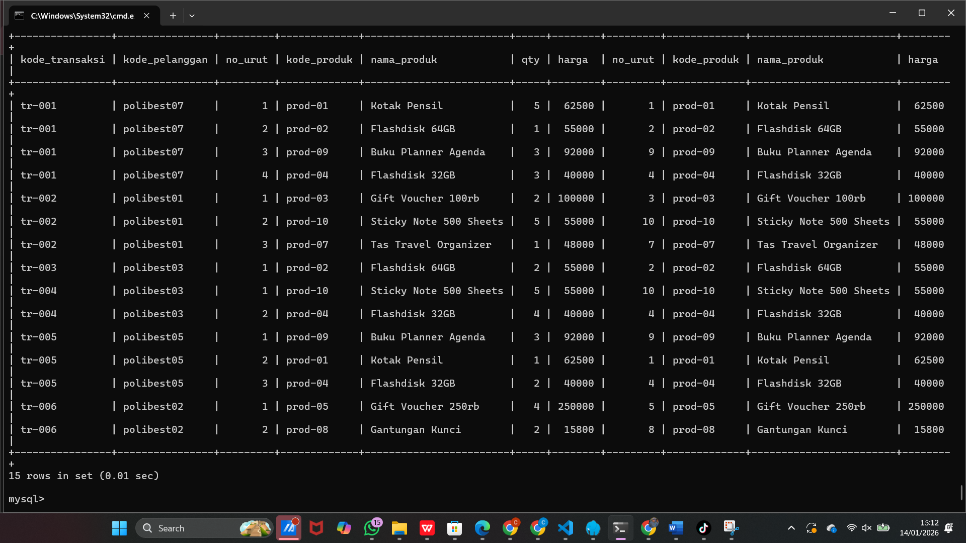
SELECT
-> tr_penjualan.kode_transaksi,
-> tr_penjualan.kode_pelanggan,
-> tr_penjualan.no_urut,
-> tr_penjualan.kode_produk,
-> ms_produk.nama_produk,
-> tr_penjualan.qty,
-> ms_produk.harga,
-> ms_produk.no_urut,
-> ms_produk.kode_produk,
-> ms_produk.nama_produk,
-> ms_produk.harga
-> FROM tr_penjualan, ms_produk
-> WHERE tr_penjualan.kode_produk = ms_produk.kode_produk;
